**Format for uploading details in Github and Slack in word file format**

**(Fill this format(docx) daily and upload it in both Github and Slack)**

**Student Name : Rani M.D**

**Class and Sec : VI B**

**USN : 4AL17CS075**

|  |  |  |  |  |
| --- | --- | --- | --- | --- |
| **Online Test Details** | | | | |
| **Subject** | **CNSC** | | | |
| **Semester** | **VI -B** | | **Duration** | **45 Minutes** |
| **% of marks** | | **-** | | |

**Encl : snapshot of the test result**

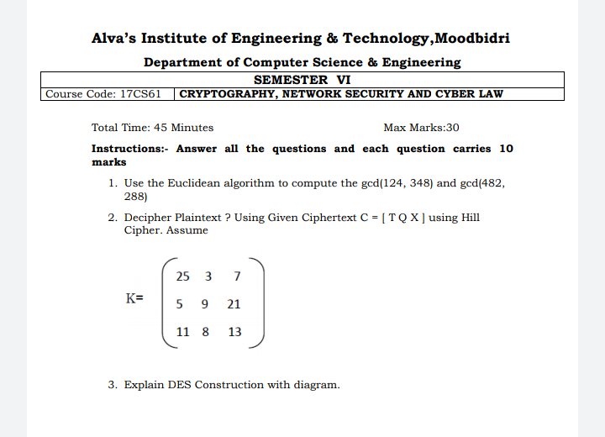

|  |  |  |  |
| --- | --- | --- | --- |
| **Certification Course Details** | | | |
| **Course** | **Webinar on Salesforce - Job ready program** | | |
| **Certificate Provider** | [**https://www.salesforce.com/in/**](https://www.salesforce.com/in/) | **Duration** | **02 hours** |

**Encl : snapshots of the daily class acitivities (atleast two snap shots)**

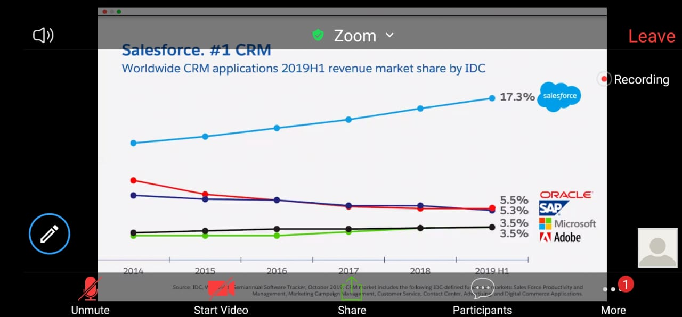

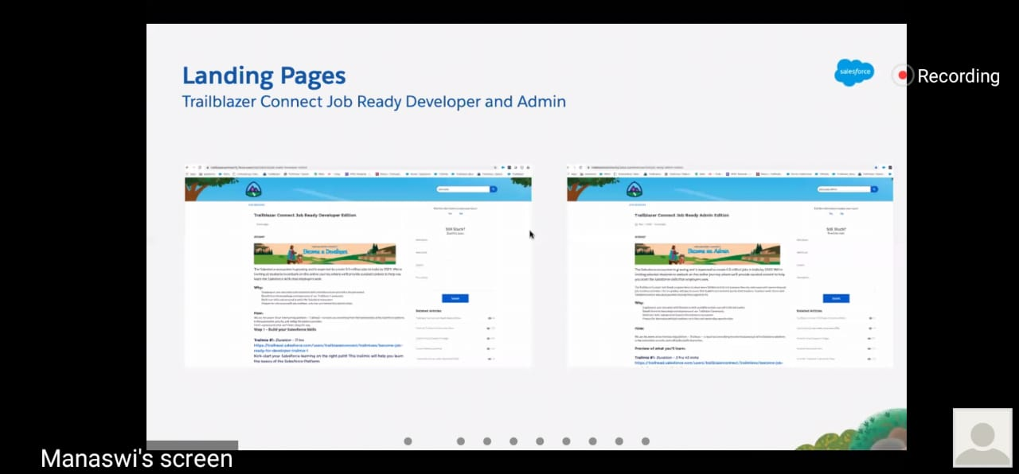

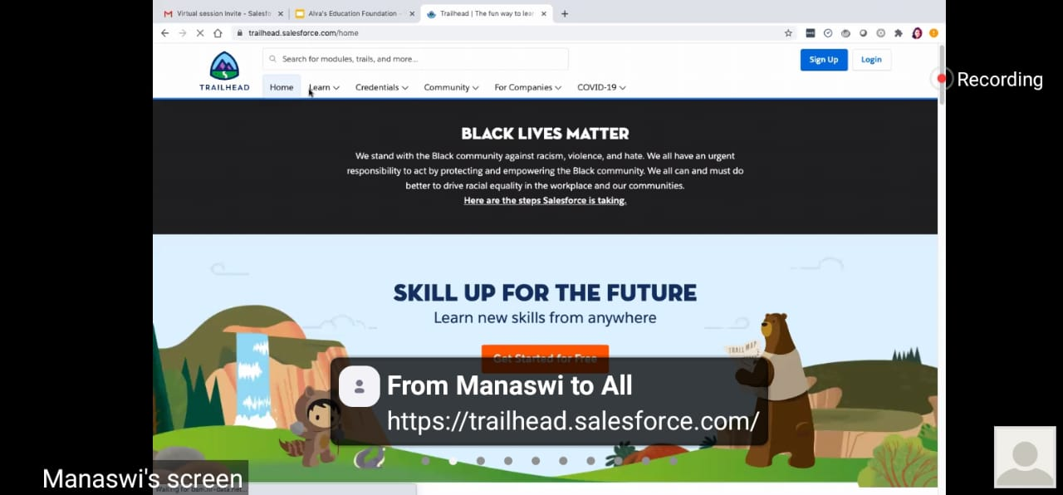

|  |  |
| --- | --- |
| **Coding Challenges** | |
| |  | | --- | | **Problem Statement : 1. Python Program to Append, Delete and Display Elements of a List Using Classes** | | |
| **Status: Completed** | |
| **Uploaded the report both in Github & Slack** | **Yes** |

**Encl : snapshots of your response to challenge.**

